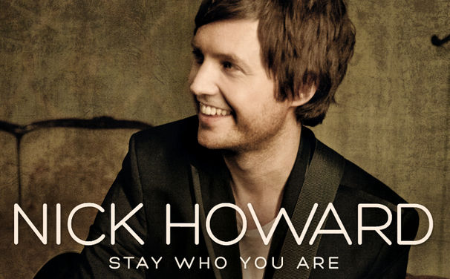
Biography

Nick Howard is an English singer (born 1982, Brighton). He is an experienced Producer and Record label manager. With a Commercial Studio in Bristol, Nick Has been recording and using music technology for ten years, and also has worked as a proffessional DJ for almost 15 years.

Lyrics

Friends remain they linger, to hear my last refrain
Die away before they step back into the rain
Their kindness is what I depend on
For no one remembers, the singer, just the song
Stay who you are
You'll break my heart if you change
The world can be cruel, lonely
Loving you only
By taking away what's true
Stay who you are
Stay who you are
More money everybody needs, the maze which we get lost in feeds
The clichés that we swallow as we follow our dreams
The dreams you carry on your back, are heavy but you live with that
Till someone who is out there sings along
Stay who you are
You'll break my heart if you change
The world can be cruel, lonely
Loving you only
By taking away what's true
Stay who you are
Yea, stay who you are
Stay who you are
Stay who you are
So if you feel like a shadow you should know that I'm near,
Know I can see you from the back row here
So dream on… so dream on…
Stay who you are
You'll break my heart if you change
The world can be cruel, lonely
Loving you only
By taking away what's true
By taking away what's true
Stay who you are
Stay who you are
Stay who you are
Come on and stay who you are
Ooh, stay who you are
Ooh, stay who you are

