THE BRITISH
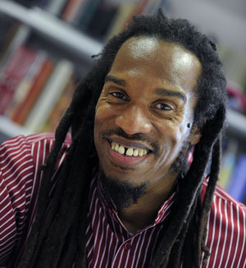
Serves 60 million

Take some Picts, Celts and Silures
And let them settle,
Then overrun them with Roman conquerors.

Remove the Romans after approximately 400 years
Add lots of Norman French to some
Angles, Saxons, Jutes and Vikings, then stir vigorously.

Mix some hot Chileans, cool Jamaicans, Dominicans,
Trinidadians and Bajans with some Ethiopians, Chinese,
Vietnamese and Sudanese.

Then take a blend of Somalians, Sri Lankans, Nigerians
Poet Benjamin Zephaniah
And Pakistanis,
Combine with some Guyanese
And Turn up the heat.

Sprinkle some Fresh Indians, Malaysians, Bosnians,
Iraqis and Bangladeshis together with some
Afghans, Spanish, Turkish, Kurdish, Japanese
And Palestinians
Then add to the Melting Pot.

Leave the ingredients to simmer.

As they mix and blend allow their languages to flourish
Binding them together with English.

Allow time to be cool.

Add some unity, understanding and respect for the future,
Serve with justice
And enjoy.

Note : All the ingredients are equally important. Treating
One ingredient better thatn another will leave a bitter
Unpleasant taste.
Warning : An unequal spread of justice will damage the
People and cause pain. Give justice and equality to all.

« The Art of Cooking », by Benjamin Zephaniah,
Wicked World (2000)

