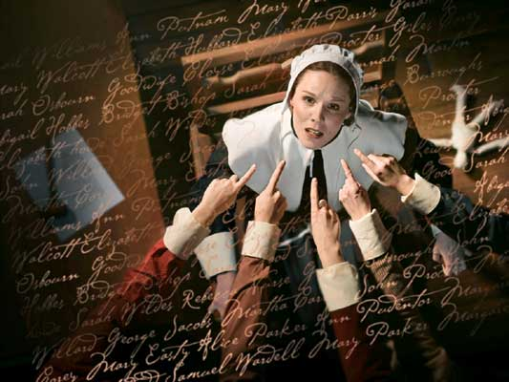
The crucible by Arthur Miller Act 1, scene 1

Tituba :My Betty be hearty soon?

Parris: Out of here!

Tituba: My Betty not goin.’ die...

Parris,: Out of my sight!. Out of my -.Oh, my God! God help me! Betty. Child.
Dear child, Will you wake, will you open up your eyes! Betty, little one...

Abigail: Uncle? Susanna Walcott’s here from Doctor Griggs.

Parris: Oh?. Let her come, let her come.Come in Susanna

Parris: What does the doctor say, child?

Susanna: He bid me come and tell you, reverend sir, that he cannot discover no medicine for it in his books.

Parris: Then he must search on.

Susanna: Aye, sir, he have been searchin.’ his books since he left you, sir. But he
bid me tell you, that you might look to un-natural things for the cause of it.

Parris: No - no. There be no unnatural cause here. Tell him I have sent for Reverend Hale of Beverly, and Mr. Hale will surely confirm that. Let him look to medicine and put out all thought of unnatural causes here. There be none.

Susanna: Aye, sir. He bid me tell you.

Abigail: Speak nothin.’ of it in the village, Susanna.

Parris: Go directly home and speak nothing of unnatural

Parris: Go directly home and speak nothing of unnatural causes.

Susanna: Aye, sir. I pray for her.

Abigail: Uncle, the rumor of witchcraft is all about; I think
you.’d best go down and deny it yourself. The parlor.’s packed with people, sir. I.’ll sit
with her.

Parris: And what shall I say to them? That my daughter and my niece I discovered dancing like heathen in the forest?

Abigail: Uncle, we did dance; let you tell them I confessed it - and I.’ll be whipped if I must be. But they.’re speakin.’ of witch-craft. Betty.’s not witched.

Parris: Abigail, I cannot go before the congregation when I know you have not
opened with me. What did you do with her in the forest?

Abigail: We did dance, uncle, and when you leaped out of the bush so suddenly,
Betty was frightened and then she fainted. And there.’s the whole of it.

Parris: Child. Sit you down.
Abigail: I would never hurt Betty. I love her dearly.

Parris; Now look you, child, your punishment will come in its time. But if you
trafficked with spirits in the forest I must know it now, for surely my enemies
will, and they will ruin me with it.

Abigail: But we never conjured spirits.

Parris: Then why can she not move herself since midnight? This child is
desperate! Abigail lowers her eyes. It must come out - my enemies will bring it
out. Let me know what you done there. Abigail, do you understand that I have
many enemies?

Abigail: I have heard of it, uncle.

Parris: There is a faction that is sworn to drive me from my pulpit. Do you
understand that?

Abigail: I think so, sir.

