The Fight to Vote

Women suffragists changed the United States
March 01, 2013
By Nellie Gonzalez Cutler
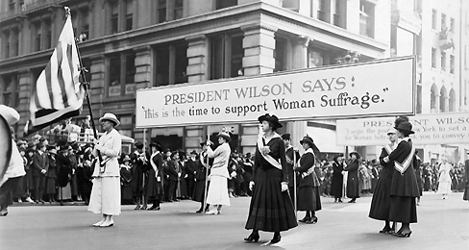
Women suffragists marched in the streets across the nation.
"We hold these truths to be self-evident: that all men are created equal." With those words, the Declaration of Independence set forth the idea of equality. But the women at the Woman's Rights Convention in Seneca Falls, New York, in 1848, felt that a key phrase was missing. Elizabeth Cady Stanton, Lucretia Mott and others rewrote the Declaration. "All men and women are created equal," they insisted. They resolved that it was "the duty of the women of this country" to fight for suffrage, or the right to vote.
Seneca Falls was the beginning of a long road to suffrage. Those who wanted to expand voting rights to all Americans were called suffragists. Suffragists demonstrated, gave talks and traveled the country.
In 1872, Susan B. Anthony voted in Rochester, New York. She was arrested and convicted of breaking the law. "My natural rights, my civil rights, my political rights, my judicial rights, are all alike ignored," she said at her trial.
Six years later, Senator A.A. Sargeant, of California, introduced an amendment to the Constitution to ensure that women could vote. But it took another 42 years before all women in the U.S. were guaranteed the right to vote.
On November 2, 1920, 8 million American women voted in a presidential election for the first time. The women who blazed the trail did not live to see that historic day. In her last speech, one month before she died, in 1906, Anthony urged women to continue to fight for the vote. "Failure," she told her audience, "is impossible."
One Step at a Time
Women worked hard to get the vote. Here are some of the main events.
1848 The Woman's Rights Convention is held in Seneca Falls, New York. Elizabeth Cady Stanton writes the Declaration of Sentiments.
1869 Stanton and Susan B. Anthony (shown) form the National Woman Suffrage Association (NWSA). Only women can join. Lucy Stone forms the American Woman Suffrage Association (AWSA). It is open to men and women.
1872 Anthony and supporters vote in the presidential election. They are arrested.
1878 A woman suffrage amendment is first introduced in the U.S. Congress.
1890 The NWSA and AWSA merge to form the National American Woman Suffrage Association.
1912-14 Women hold rallies in New York City and Washington, D.C.
1917 Police arrest women who are picketing outside the White House. By 1918, about half the states have granted full or partial voting rights to women.
1919 Congress passes the 19th Amendment, called the Susan B. Anthony Amendment. It is ratified, or confirmed, one year later.
http://www.timeforkids.com/news/fight-vote/81911

